Game Design Document

Fill up the following document

1. Write the title of your project.

The last archer

1. What is the goal of the game?

Get 1000 points

1. Write a brief story of your game.

The story of the game is the archer who is the last of his kind , and he had to now face these modern soliders who want to destroy him

1. Which are the playing characters of this game?

* Playing characters are the ones who respond to the user based on the input from the user.
* Cars, monkeys, dinos, wizards, etc., are the playing characters in the game.

|  |  |  |
| --- | --- | --- |
| Number | Character Name | What can this character do? |
| 1 | archer | He shoots arrows he can jump . |
| 2 |  |  |
| 3 |  |  |
| 4 |  |  |
| 5 |  |  |
| 6 |  |  |
| 7 |  |  |
| 8 |  |  |

1. Which are the Non-Playing Characters of this game?

* Non-Playing characters are the ones that don't have an action or behavior when the user interacts with the game.
* Hurdles, stones, bananas, coins, etc., are non-playing characters in the game.

|  |  |  |
| --- | --- | --- |
| Number | Character Name | What can this character do? |
| 1 | soilders | Come towards the archer |
| 2 | diamond | Come towards the archer |
| 3 |  |  |
| 4 |  |  |
| 5 |  |  |
| 6 |  |  |
| 7 |  |  |
| 8 |  |  |

Draw your imagination of this game. What does this game look like?

* Draw the game either on your computer or on paper.
* Add images of the game scenes to show each of the playing and non-playing characters at least once.

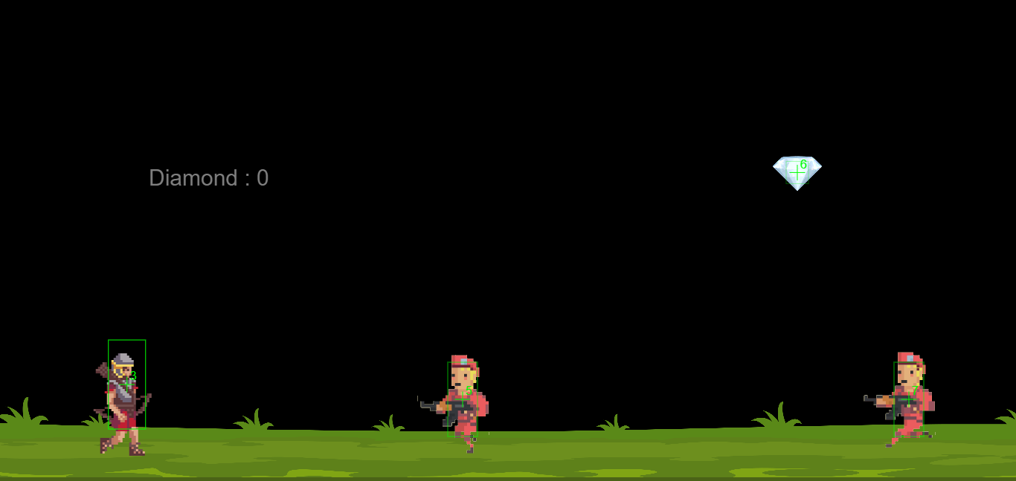

How do you plan to make your game engaging?

By making it more challenging